Power source 7-12V DC

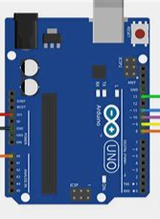

RxTx port sets

Serial comm

Analogue o/p pin

Rx

GRD

Vcc

UART comm

GRD

Tx

Vcc

CO2 sensor

EZO-CO2

Air sensor

D6FO2L2000

MAX348

RS485 TO TTL converter

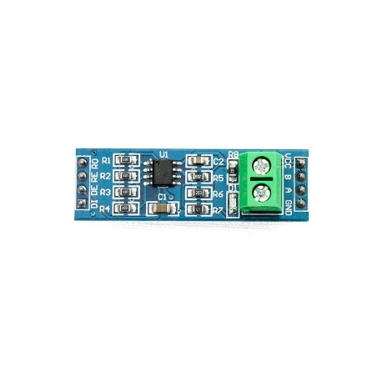

Com GRD

Rx

Power source 12-24V DC

Tx

Data enable

GRD

Vcc



Vcc

GRD

Data enable

Tx

Rx

pH sensor

Taidda soil pH

RH sensor

Wall Hu sensor